Dr. Frank Chase Jr., Th.D., and Author of Kleptomaniac: Who’s Really Robbing God Anyway receives coveted Book Excellence Award

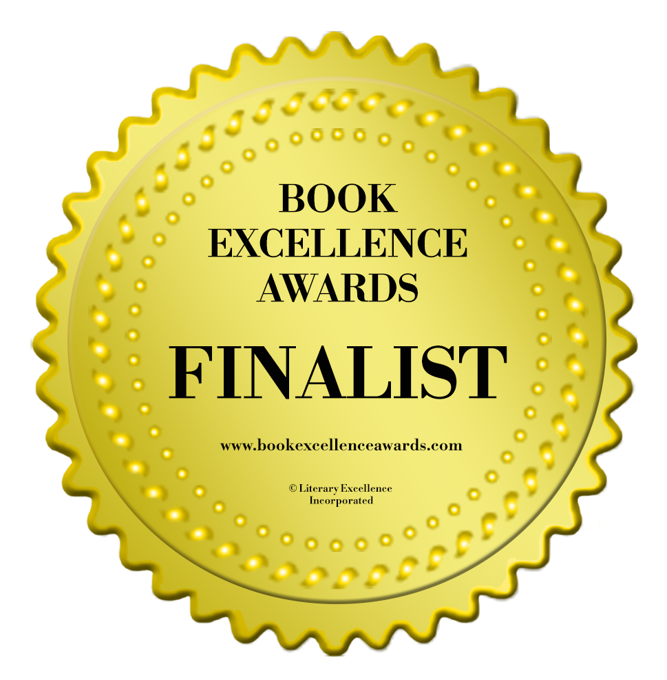

Frank Chase Jr’s book Kleptomaniac: Who’s Really Robbing God Anyway reveals hidden biblical facts about tithing that are informative and unknown, which will leave readers shocked and amazed.

Madison, 2 September 2019 – Frank Chase Jr’s, Kleptomaniac: Who’s Really Robbing God Anyway wins a Book Excellence Award in the religion category. Founded in Toronto, Ontario, the Book Excellence Awards is an international book awards competition dedicated to recognizing both independent and traditionally published authors and publishers for excellence in writing, design and overall market appeal. Previous Winners and Finalists of the Book Excellence Awards have doubled their book sales, garnered attention from film producers, received distribution in bookstores and increased their visibility and media attention.

“When I won as a finalist I was shocked. I said to myself, this is not true. I really felt proud and happy about all the work I put into this book over the years,” says, Frank Chase Jr., “The book was recognized as a finalist in the religion category because of design, writing and market appeal. Audiences will benefit from reading this book because it reveals information about monetary tithing, an understudied subject long hidden from congregations. Readers will benefit from reading the book because they will finally get forthright truth and understanding about what biblical tithing is and is not and how it was practiced in the first century among the Hebrew people of Israel. From now on Christians who question tithing will have facts, proper exegesis, hermeneutics and scriptures to properly understand tithing in its proper biblical context as livestock and crops and not as a monetary ten percent required by God,” which is why Dr. Frank Chase Jr. wrote the book.

Kleptomaniac: Who’s Really Robbing God Anyway is a book that challenges reader what they thing they know about the subject of biblical tithing. Kleptomaniac: Who's Really Robbing God Anyway? The Untwisted Truth About the Centuries Old Tithes and Offering Deception examines the history of church tithes, a practice from the early days of Christianity which takes a darker turn as its history and connections to actual Scripture are probed from its original applications to modern times. This book examines the word tithe from the original Hebrew language and presents the authentic meaning of the orthodox term based on the land, language and literature of the Hebrew people. Dr. Frank Chase Jr., gives readers insight into the orthodox Hebrew definition of tithing, how its original meaning was turned into an unauthorized monetary fundraising tool to extract money, and who the culprits are who changed this sacred practice into monetary money grab for centuries. The book helps readers, Christians and different religious groups know the difference between tithing and giving in the Bible and why paying ten percent of your income to a religious organization is not covered on the pages of the Bible.

The book has already received some great reviews from industry leaders.
“Kleptomaniac certainly has an extremely intriguing concept. The investigation of tithing in the bible, history, and modern day is a unique and not-often-thought-of idea, which is explored quite eloquently here. Dr. Frank Chase Jr., Th.D. has incredible knowledge of the bible and a vast array of excellent sources to back up his points, which only adds to the validity of his writing. Whether readers agree with Dr. Chase's views or not, it cannot be denied that he certainly provides something interesting to ponder in this book. Kleptomaniac: Who's Really Robbing God Anyway? is a thoughtful, well-researched book that is equally respectful and revolutionary in its unique approach to an age-old, unspoken question--what is the purpose of tithing really?" wrote Member of Authors Talk About It team.

To purchase Kleptomaniac: Who’s Really Robbing God Anyway visit the Book Baby website: https://store.bookbaby.com/book/kleptomanaic. You can get it on kindle, iBooks, PDF and paperback.

About the Author – Dr. Frank Chase Jr., is a native of Baltimore, Maryland. He graduated from Walbrook High School in 1978 and then enlisted and served in the United States Army for four years. He is a graduate of Washington State University and has a BA degree in Communications with a minor in Sociology. Because Frank believes in education, he pursued religious degrees and graduated from North Carolina College of Theology with a Bachelor of Biblical Studies, a Master of Arts in Theology, and a Doctor of Theology. He also started his publishing company, FC Publishing, LLC to self publish his first two books. As a writer, Dr. Chase authored his first book, False Roads to Manhood, What Women Need to Know: What Men Need to Understand, dealing with the issues of manhood. He recently published his second book titled, Kleptomaniac: Who’s Really Robbing God Anyway?

About the Book Excellence Awards – Founded in Toronto, Canada, the Book Excellence Awards is an international book awards competition dedicated to recognizing both independent and traditionally published authors for excellence in writing, design and overall market appeal. Previous Winners and Finalists of the Book Excellence Awards have been New York Times’ best-sellers, spoken at the United Nations and TEDx, and have had their books optioned by movie studios.
To learn more, visit:
https://honorees.bookexcellenceawards.com/#!/Kleptomaniac-Whos-Really-Robbing-God-Anyway-Religion/p/143373626/category=36034731.

